Python – Salesforce metadata retrieve & compare

Contents

Document control 2

Setting up the environment: 2

Installing Python: 2

Setting up Salesforce retrieve folder: 3

Setting up the code folder: 4

Using the scripts: 5

For complete pull of a single environment 5

For complete pull & compare of two different environments 6

# Document control

|  |  |  |  |  |
| --- | --- | --- | --- | --- |
| S.No | Version | Author | Date | Comments |
| 1 | Draft | Naren Karthik | 05/24/2017 | Draft version, will be revised based on feedback. |

# Setting up the environment:

The below steps needs to be completed before using the scripts.

## Installing Python:

**Step 1:** Download latest version of python (Version greater than 3.4) from<https://www.python.org/downloads/>

**Step 2:** Run the downloaded file to install python

**Step 3:** Check the box Add Python to PATH & click on Install Now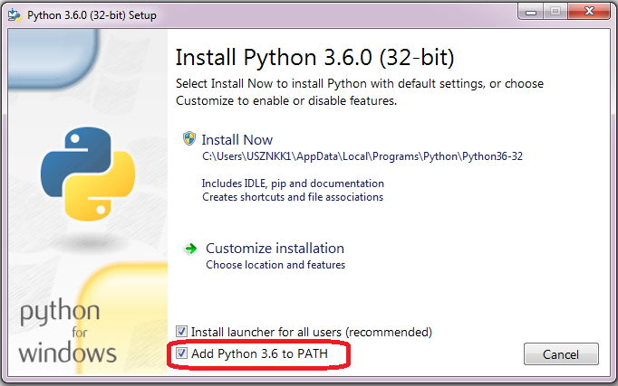

**Step 4:** Go to command prompt using (**windows button + r**) and entering **cmd**

**Step 5:** In command line type:python -m pip install -U pip setuptools

**Step 6:** In command line type:pip install xmltodict

**Step 7:** In command line type:pip install requests

**Step 8:** In command line type:pip install configparser

**Python is installed successfully. Now setup the retrieve folder!!!**

## Setting up Salesforce retrieve folder:

**Step 1:** Create a folder in your desired location in your desired name. The name SHOULD NOT have spaces.

**Step 2:** Unzip the below zip file in some location



**Step 3:** Find the “src” folder from the unzipped folder and place it inside the folder you had created in Step 1 above

**Step 4:** The “src” folder will have 3 folders 🡪 ant, login_details and reference as shown below

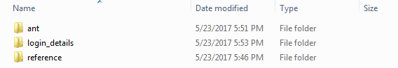

**Step 5:** Download and place latest Salesforce ant jar inside the ant folder



**Step 6:** Create one property file per environment in the below provided format. You can name is as you desire (without any spaces in the name). But do not remove [LOGIN] in the first line of the file.



**Step 7:** Place the property files inside login_details folder

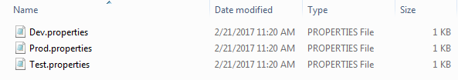

**Step 8:** Create a component file in the below provided format and name it “component_list” as save it in .txt format and place it inside the reference folder. But do not remove [COMPONENTS] in the first line of the file. You can create as many component list in the file as you wish but only the one mentioned in use variable will be used for the retrieve and compare.



**Step 9:** Copy the below reference_build.xml and place it inside the reference folder. DO NOT edit/modify the reference_build.xml.



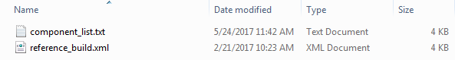

**Retrieve folder setup is completed successfully. Now setup the code folder!!!**

## Setting up the code folder:

**Step 1:** Unzip the below zip file in some location



**Step 2:** Find the “code” folder from the unzipped folder and place it inside the folder you had created in step 1 of the “Setting up Salesforce retrieve folder” section

**Code folder setup is completed successfully and we are all set to run the script!!!**

# Using the scripts:

So let’s assume you installed Python and you have created a desired folder named “salesforce_retreive” in C drive and placed the unzipped “src” folder and “code” folder inside this folder and completed all the above setup steps.

**Please note:** The following 4 metadata components won’t be pulled as of yet as they follow a different storage/retrieval pattern in Salesforce.

1. Dashboard
2. Document
3. EmailTemplate
4. Report

**Step 1:** Go to command prompt using (**windows button + r**) and entering **cmd**

**Step 2:** Go to the “code” folder by typing: cd <Code folder path> and hit ENTER

For the above scenario it will be 🡪 cd C:\salesforce_retreive\code

## For complete pull of a single environment

**Step 2a:** Type: python complete_pull_env.py <desired folder path> <environment_property_file_name> and hit ENTER

For the above setup let’s say you want to pull “test” environment, then it will be

🡪 python complete_pull_env.py “C:\salesforce_retreive” test

**Please note:** It will only pull the components which are provided through “use” parameter in the “component_list.txt” inside the reference folder.

**Step 3:** Once it is done, the retrieve output will be saved in a folder name as today’s date inside in complete_pull folder which will be inside the folder you had created in step 1 of the “Setting up Salesforce retrieve folder” section

For the above scenario it will be stored under

🡪 C:\salesforce_retrieve\complete_pull

## For complete pull & compare of two different environments

**Step 2a:** Type: python compare_retrieve_envs.py <desired folder path> <source_env> <target_env>

For the above setup let’s say you want to pull and compare between “test” and “dev” environments, then it will be

🡪 python compare_retrieve_envs.py “C:\salesforce_retreive” test dev

**Please note:** It will only pull & compare the components which are provided through “use” parameter in the “component_list.txt” inside the reference folder.

**Step 3:** Once it is done, the retrieve and compare output will be saved in a folder name as today’s date inside in retrieve_compare folder which will be inside the folder you had created in step 1 of the “Setting up Salesforce retrieve folder” section

For the above scenario it will be stored under

🡪 C:\salesforce_retrieve\retrieve_compare